3B Physics: Particles, Waves and Quanta

Assignment One
Name: Possible Answer Key

- Replace the following statements with a single word. (5 marks)

- Maximum displacement a particle moves from its mean position amplitude
- Area of sound wave where particles move together. compression
- Type of wave where particle displacement is perpendicular to the
direction of energy. transverse
- Distance between two successive points on distance/displacement
graph. wavelength
e. Distance between two successive points on distance/time graph. period
f. Combination of two waves that meet and form composite wave. interference
g. Part of standing wave where displacement of particles is zero. node
h. Multiples of a fundamental frequency. harmonics
i. Waxing and waning of sound caused by sounds of similar frequencies. beats
- Frequency of driving force coincides with natural frequency of body
being force to vibrate increasing vibrations. resonance
- Determine the amplitude and wavelength in the following wave.
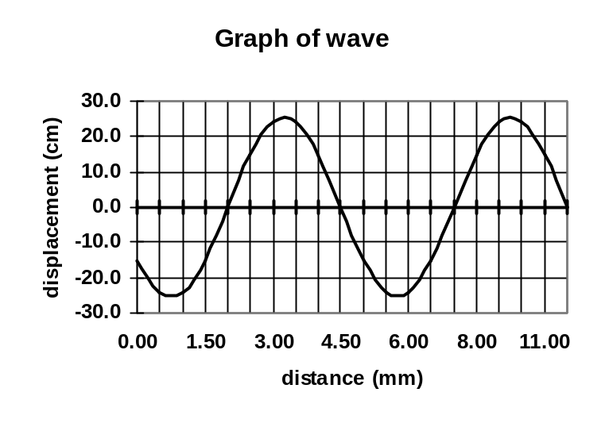

Wavelength: 5.00 x 10⁻³ m

Amplitude: 2.50 x 10⁻¹ m

- While watching waves, a walker sees the waves arriving on the beach every 2.00 seconds and the distance between crests to be 10.0 m. What is the speed of the wave? (2 marks)

v = fλ
= 0.50 x 10
v = 5.00 m s⁻¹

- List three differences between sound waves and light waves. (3 marks)
- speed
- sound mechanical wave, light an electromagnetic wave
- sound needs a medium, light doesn’t
student may also discuss how each is produced e.g. light: wave of changing electric and magnetic fields. Sound: longitudinal wave travelling on particles.
- Complete the following wave diagrams then underneath the diagram write the name of the wave behaviour that is occurring.

Waves passing through an opening  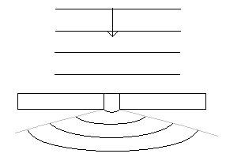 | Person above aquarium listening to noisy fish.  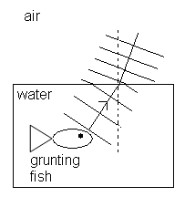 | Waves reflected on a circular wall.  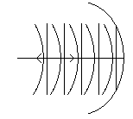

- Draw the resultant wave over the top of this diagram of two waves. (2 mark)
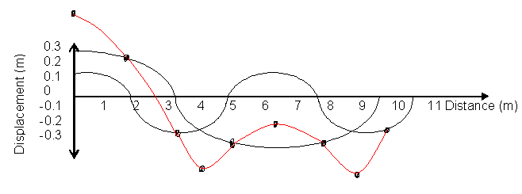

- An organ pipe, open at both ends, produces the middle C note (256 Hz) when sustaining a standing wave at its third harmonic.
- Draw a diagram to represent the standing wave in the pipe in its third harmonic, labelling the nodes and antinodes. (2 mark)

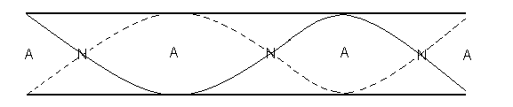
- Calculate the fundamental frequency of the organ pipe. (2 mark)

f_{f} = 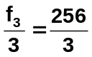
f_{f} = 85.3 Hz

- A student sets up an experiment using a large pipe in a tall cylinder of water. She sounds a 640 Hz tuning fork over the top of the tube and slowly raises the tube until the resonance of the fundamental frequency is heard. (Speed of sound in air is 342 ms⁻¹).
- What is resonance? (2 marks)

Resonance is when something, such as the air in the pipe, is forced to oscillate and the oscillations match the natural frequency e.g. the air in the pipe at a particular length. When resonance occurs, the oscillations increases significantly and a sound can be heard from the pipe.

- What length of pipe will be above the water? (2 marks)

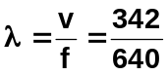 = ¼ λ
λ = 0.5344 m = 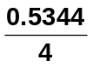
= 0.134 m

- If the pipe is 70.0 cm long, how many harmonics would be heard? (2 marks)

for f_{f} ; = ¼ λ = 0.134 m You can therefore see
f₃ ; = ¾ λ = ¾ x 0.5344 = 0.401 m that as f₇ is too long,
f₅ ; = λ = x 0.5344 = 0.668 m you will hear fundamental
f₇ ; = 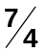λ = 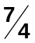 x 0.5344 = 0.935 m and two harmonics.

- Two violins strings of the same note are played, but a loud – soft sound is heard.
What is the name given to this phenomena and why does it occur? (2 mark)

Beat.
The two strings are slightly out of tune (have slightly different frequencies). These two waves interfere with each other producing beats.

- A guitar string plucked so that it produces it fundamental frequency of 216 Hz. If the speed of sound on that day was 346 ms⁻¹, what was the length of the string? (2 marks)

f = 216 Hz 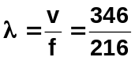 = ½ λ
v = 346 m s⁻¹ = 1.60185 m = 0.5 x 1.60185
= 0.810 m

- A bass trombone (T) which has a low frequency range and a piccolo (P) which has a high frequency range are being played in a room which has the door open. You were standing at X (in the diagram below).
X

room viewed from P
above T

- Which of the instruments would you hear better if they were playing with the same loudness? Trombone (1 mark)
- Name the physical phenomenon which led you to choose either the trombone or the piccolo and explain why you chose your answer.

Name: diffraction (1 mark)
Explanation:
Lower frequencies diffract more than high frequencies as their wavelengths are closer to the width of the door and diffract more.
(lower frequencies are less directional) (2 mark)

- Two loud speakers of the same frequency are set up facing each other to produce a standing wave. The speakers are 2.0 m apart and have a frequency of 680 Hz. The speed of sound is 340 ms⁻¹.
- As you move from speaker to speaker, you hear loud and soft sounds. Explain why.
Due to standing waves being set up which are areas of reinforcement (loud sound) and areas of annihilation (soft sound) (2 marks)

- What is the wavelength of this sound? (2 mark)

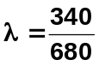
λ = 0.50 m

- Assuming an anti-node has been created at each speaker, how many times will the sound go soft as you move from speaker to speaker. (2 marks)
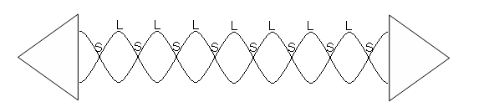
As you can see from the diagram above, the sound goes soft 8 times.

